

**AD Project Proposal**Team 6

**Project Title**Food Share

**Project Lead**Engelbert  
[engelbertteh@gmail.com](mailto:engelbertteh@gmail.com)

**Project Members**

Jason Tay Neng Wei  
  
Meng Xianzhu

Paing Zay

Wathanta Aung

Xie Wenwen

Xu Bingxin

* 1. **Problem statement**

According to U.S. Department of Agriculture, *food insecurity* is an economic or social condition in which individuals would have limited or uncertain access to safe and adequate food (USDA ERS, 2022). In a study published by SMU's LCSI and The Food Bank Singapore in 2020, 10.4% of Singaporean households were reportedly experiencing food insecurity (Sidhu et al., 2022). On the other side of the spectrum, food wastage is another issue Singapore is facing, i.e., on average 700,00 to 800,000 tonnes of food are wasted every year (see Table 1).

There were initiatives by governmental and non-governmental organizations to tackle these issues, and we would like to be part of these initiatives. We believe that excess edible food that would be thrown away by individuals or businesses could actually be redistributed to people who needed it instead. Therefore, we would need to create an application that creates awareness to people and businesses, enables them, and let them be a part of this movement to reduce food wastage by channeling excess food to people who needed it instead. Furthermore, we would also need to ensure our implementation of this technology does not affect businesses in a negative way.

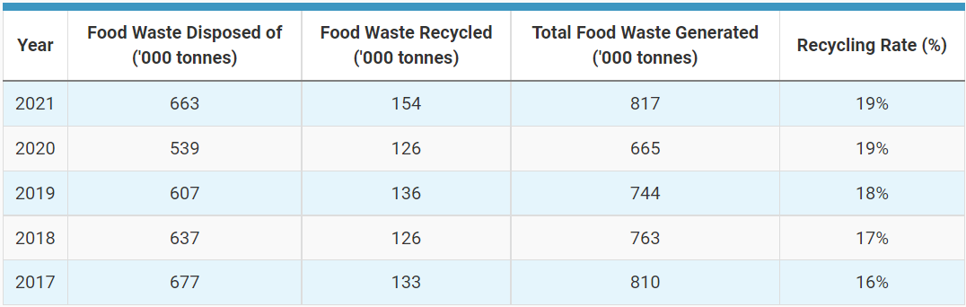

*Table 1*: Table showing the statistics on the amount of food waste Disposed of, Recycled and Generated in the past 5 years. From "Food Waste Management", by National Environment Agency, 2022.

**Business logic**

**Introduction**

The *app* to be developed will be based on two business models that cater to three different end users. The first type of end users are the *receivers;* they are the individuals who will receive the food products. Individuals known as *givers* are the second type of end users. Givers would list the foodthey would want to give away through the app (see **Appendix B**)*,* and a receiver would then need to make a request for the selected food item by messaging the respective giver. The giver would state the time and place to pick-up the food through the app's messaging system. The receiver would then proceed to collect the food within the agreed time. This basically explains the first business model.

The second business model (also known as the enterprise version) is meant to cater to businesses and enterprises such as restaurants, food stalls, supermarkets, or organizations that have extra food that they would like to give away. These businesses and enterprises are the third type of end users that use the app. The difference between this business model and the former is that it would require us to be an intermediary between them and the receivers.

The second business model is designed to especially target businesses that would prefer a free alternative in managing their *food waste*. The advantages of using the enterprise version of the app are twofold:   
Firstly, services will be provided to collect food from their business premises;   
Secondly, the image or reputation of these businesses will be protected because the food collected will be filtered to ensure edibility and redistributed to receivers without the receivers actually knowing where the food came from.

To summarize, the abstraction layer protects businesses because it hides their identity (so these businesses would not be liable if receivers claimed to have food poisoning after consuming the freely provided food), and at the same time, businesses do not need to pay highly-charged fees to contractors for handling their food waste.

|  |  |  |  |
| --- | --- | --- | --- |
| **Business Model 1: Givers-to-Receivers (G2R)** | | | |
|  | **Major** | **Medium** | **Low** |
| 1 | Register Users | Manage Account | Filter Preferences |
| 2 | Authenticate Users | Manage Food Listing | Send Push Notification |
| 3 | View Dashboard | Moderate Listing | Prioritize |
| 4 | Create Food Listing | Reward Users | Report Users |
| 5 | Find Food | Predict Hotspots |  |
| 6 | Message Users | Manage Users |  |

**Services and features**

*Table 2:* Table showing main use cases sorted according to their priority levels with respect to the business value they will or potentially could provide in G2R business model. Refer to **Appendix A** for detailed information of respective features.

**Services and features**

|  |  |  |  |
| --- | --- | --- | --- |
| **Business Model 2: Enterprise-To-Collectors-To-Receivers(E2R)** | | | |
|  | **Major** | **Medium** | **Low** |
| 1 | Register Users | Manage Account | Filter Requests |
| 2 | Authenticate Users | Manage Submitted Request | Send Push Notification |
| 3 | View Dashboard | Manage Response |  |
| 4 | Request For Collection | Manage Users |  |
| 5 | Respond To Requests |  |  |
| 6 | Message Users |  |  |

*Table 3:* Table showing main use cases sorted according to their priority levels with respect to the business value they will or potentially could provide at the enterprise level. Refer to **Appendix A** for detailed information of respective features.

**A high-level use case diagram**

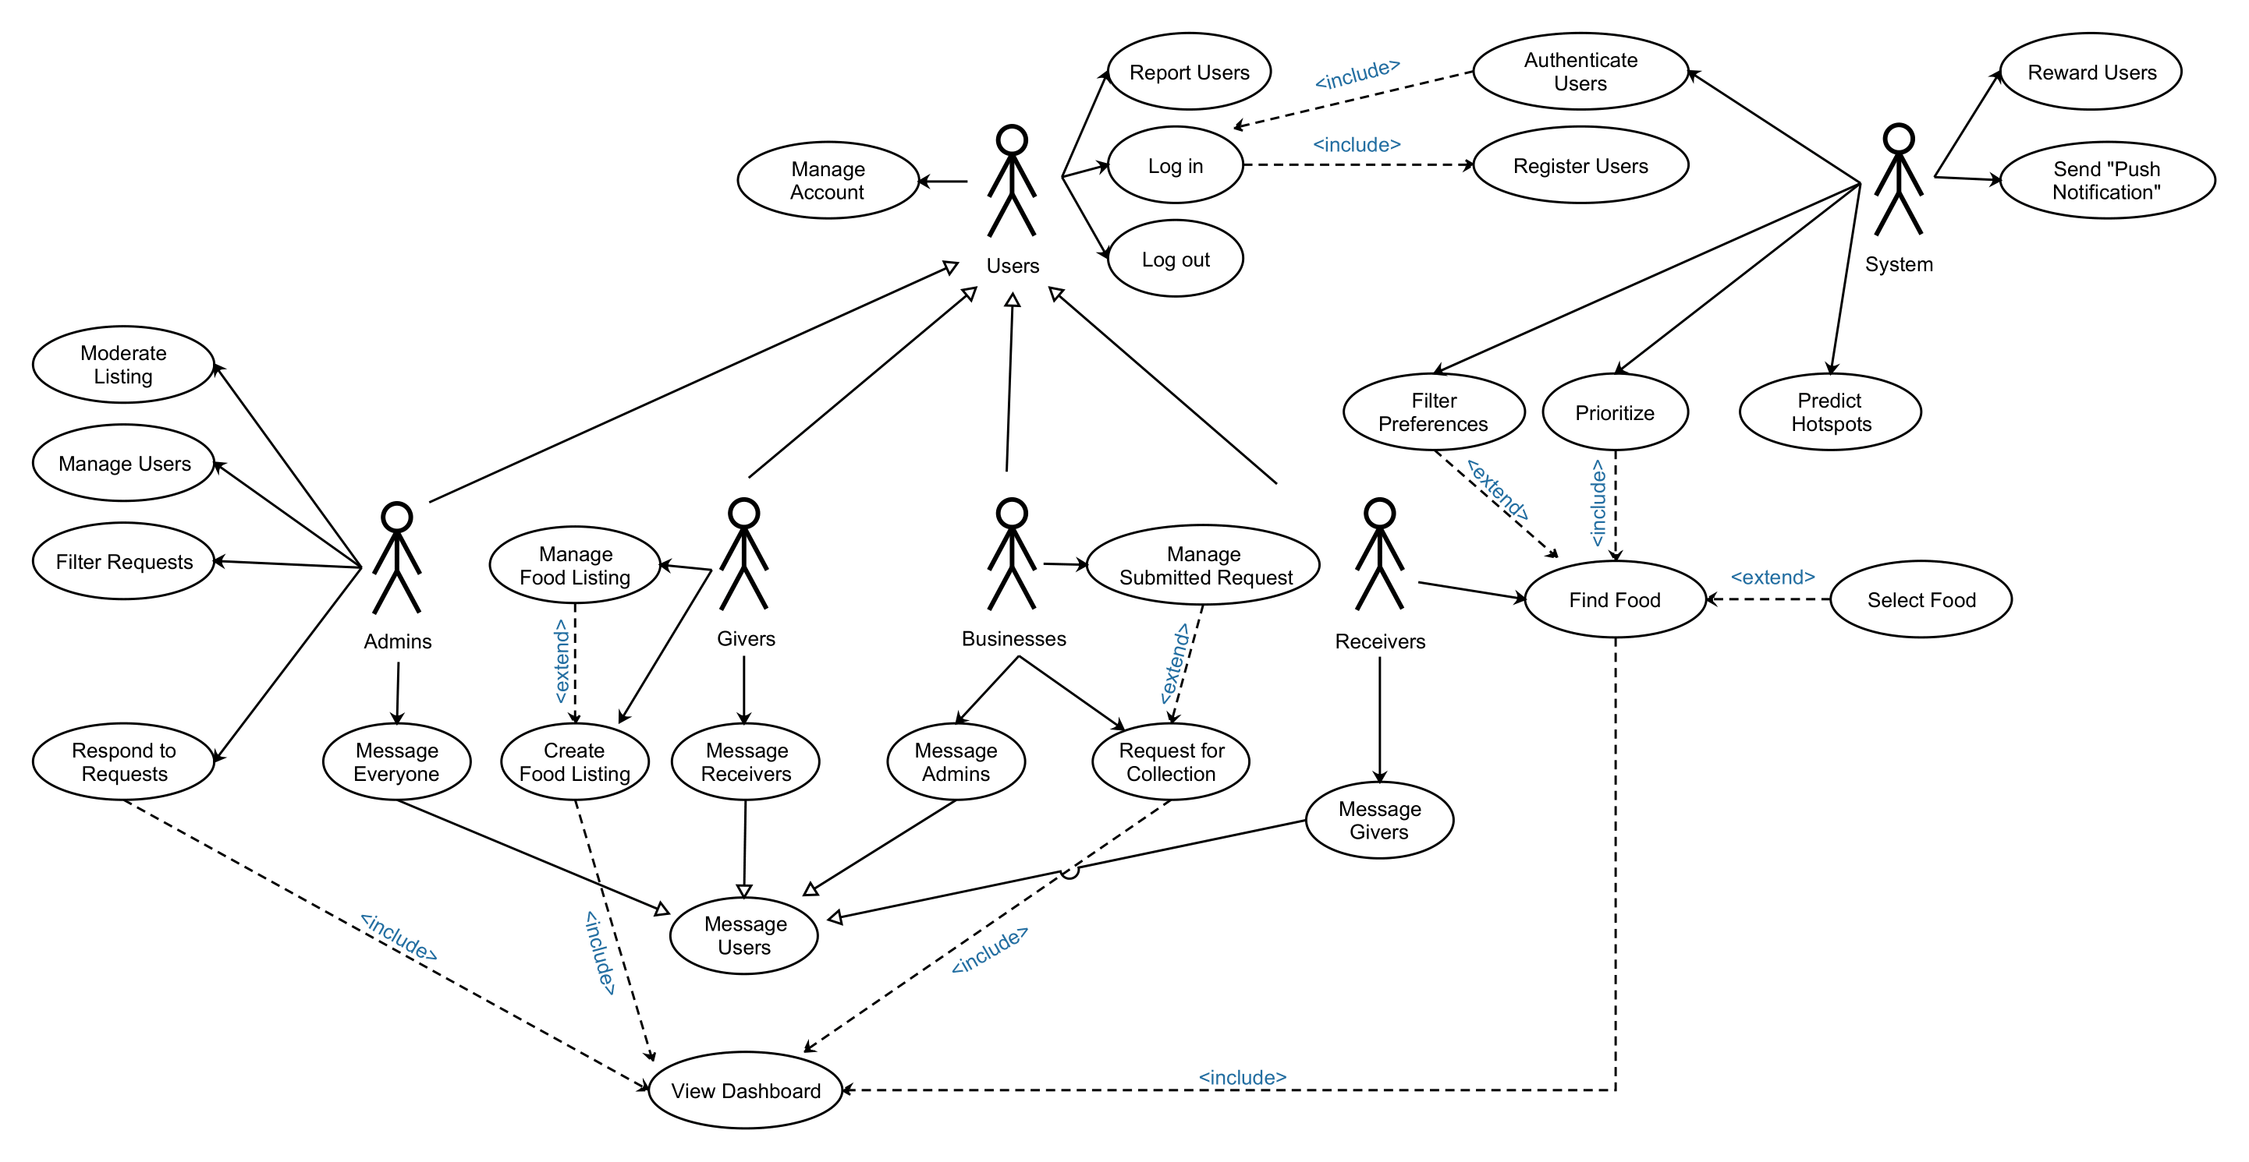

|  |  |  |  |  |  |  |
| --- | --- | --- | --- | --- | --- | --- |
| * 1. **Application Type** | * 1. **Front End** | * 1. **Back End** | * 1. **Server** | * 1. **Database** | **Machine Learning** | **Deployment** |
| * 1. Web App | * 1. React | * 1. Spring | * 1. Apache EE | * 1. MySQL/MSSQL | * 1. ScikitLearn/Keras | Railway |
| * 1. Mobile App | * 1. Android/ React Native | * 1. Spring | * 1. Apache EE | * 1. MySQL/MSSQL | * 1. ScikitLearn/Keras | Google Playstore |

* 1. **Scope and Technologies**

**Definitions**

1. "**Admins**" refers to the administrators managing the app.
2. "**App**" refers to the *Food Share* app.
3. "**App-Owner**" means the person(s) or organization(s) owning the app.
4. "**Food**" means food, foodstuffs, or drinks.
5. "**Food Share**" refers to an activity in which Food is transferred over from the Giver to the Receiver.
6. "**Food waste**" refers to Food that is fit for consumption but consciously discarded at the retail or consumption phases.
7. "**Giver**" means a person or enterprise who Offers Food.
8. "**Offer**" means offering Food(s) to Receivers by listing it on the app.
9. "**Receiver**" means a person who receives Food.
10. "**Users**" refers to both receivers and givers.

**Appendix A**

1. Authenticate Users  
   - Login authentication
2. Create Food Listing  
   - Create a post to display food items to be given away, may include pictures and details.
3. Filter Preferences  
   - Filters out food selections according to receivers' food preference (halal/non-halal) and distance preference. It is also able to sort food selections by distance or by recency.
4. Filter Requests  
   - Filters requests made by enterprises by company name, food type, collection date/time, etc.
5. Find Food  
   - Displays food listing for receivers to select.
6. Manage Account  
   - To allow users to change their account settings, e.g., password, username, personal details, etc.
7. Manage Food Listing  
   - Allows non-enterprise givers to manage the food they posted on the listing.
8. Manage Submitted Request  
   - Allows enterprise givers to edit or configure the submitted request for food collection.
9. Manage Users  
   - Allow the admins to manage the userbase, e.g., remove users.
10. Message Users  
    - Allows users, including the admins, to interact with one another through a messaging system.
11. Moderate Listings  
    - Allows admins to moderate posts on the food listing. Admins are given the authority to remove posts with explicit, inappropriate, or vulgar content.
12. Predict Hotspots  
    - Helps receivers to identify locations where Food Share activities would potentially take place, e.g., displaying *Jurong East St 21* on receiver's dashboard, indicating that this area could potentially have high volume of Food Share activities taking place in the future within a certain time period.
13. Prioritize  
    - For receivers in the low-income group, this feature will be activated implicitly.  
    - If activated, allows receivers to view all food posts in the listing.  
    - If deactivated (default state), allows receivers to view all food posts in the listing but hides recently posted food.
14. Report Users  
    - Allow users to report other users, e.g., a giver reporting a receiver for not showing up after making an appointment for food pick-up.
15. Register Users  
    - Registers new users and store details into a cloud database system.  
    - For receivers, to identify low-income groups, payslips are to be shown for verification. For no-income groups, they will need to come over to our office for further verification, and to provide extra assistance if it’s a genuine case.  
    - More details required for businesses to register, e.g., business name, phone number, email address, address, store type (e.g., restaurant, bakery, supermarkets), opening-days, routine pick-up time and day, etc.  
    - Users are required to key in a One-Time-Password into the app to complete the registration.
16. Respond To Requests  
    - Admins to accept givers request for food items collection at their premises within the specified date and time.
17. Reward Users  
    - Monthly frugal medal (users who use the app with high stickiness, including food givers and food receivers).  
    - Influencer rewards (those who share the app with more than 5 of their friends or followers).  
    - Quests for food givers (Weekly quest, get rewards if quest accomplished, promotes food charity/sharing).   
    - Scoreboard to track reward points/progress (option to not be included in the scoreboard.
18. Request For Collection  
    - Allows enterprise givers to make food collection requests, specifying the food details in their submission.
19. Send Push Notification  
    - System to send push notifications to users or admins.
20. View Dashboard  
    - Allows users and admins to view their respective dashboards.

**Appendix B: Activity Diagram**

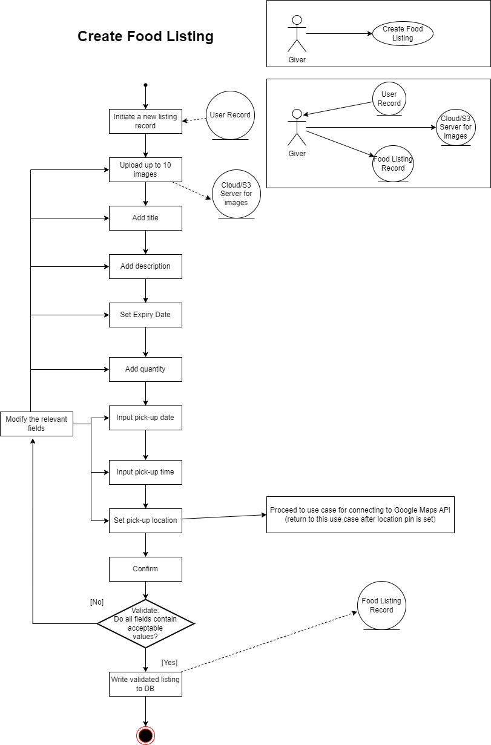

**References**

National Environment Agency. (2021, October). *Food Waste Management Strategies*. <https://www.nea.gov.sg/our-services/waste-management/3r-programmes-and-resources/food-waste-management/food-waste-management-strategies>

OLIO. (2022). *OLIO – The #1 Free Sharing App*. https://olioex.com/

Sidhu, Nagpaul, Ng, & Wewalaarachchi. (2022, March). *The hunger report part II: Targeting specific needs in the wake of COVID-19*. <https://ink.library.smu.edu.sg/cgi/viewcontent.cgi?article=1017&context=lien_reports>

Tong, Y. W. (2022, October 2). *Food Waste to Resources*. NUS Environmental Research Institute. <https://nus.edu.sg/neri/research-features/food-waste-to-resources/>

USDA ERS. (2022). *USDA ERS - Definitions of Food Security*. <https://www.ers.usda.gov/topics/food-nutrition-assistance/food-security-in-the-u-s/definitions-of-food-security/>